Img operator -> Seam carving suggests content-aware resizing for 🡪 🡨 and 🡨🡪

Seam 🡪 8-connected Path

Optimality is defined by an energy function

* Order of seams in an image is stored to create multi-size images, that are able to continuously change in real time to fit a given size.

Types of energy functions:

1. Gradient magnitude
2. Entropy
3. Visual saliency
4. Eye-gaze movement

Top down method – face detectors

Bottom up method rely on visual saliency

Saliency Map

Energy function: 

X (vertical seam) is a mapping **x: [1,…,n] 🡪 [1,…,m]** 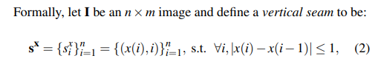

* a vertical seam is an 8-connected path of pixels in the image from top to bottom, containing one, and only one, pixel in each row of the image

Y (Horizontal seam) is a mapping **y: [1,…,m] 🡪 [1,…,n]** 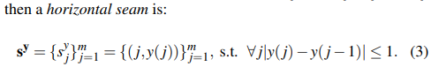

* removing the pixels of a seam from an image only has a local effect: all of the pixels of the image are SHIFTED to the left (or up) to compensate for the missing path

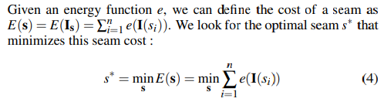

Optimal seam can be found using DYNAMIC PROGRAMMING.

